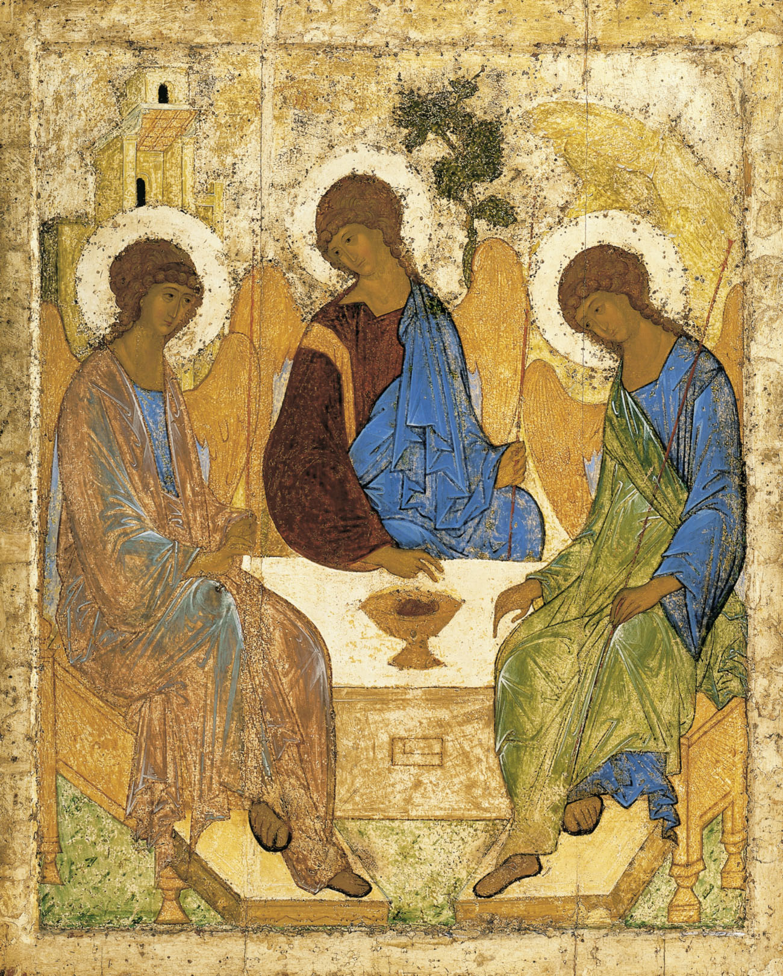
Holy Communion
at Holy Trinity Church, Jersey
Trinity Sunday
15th June 2025


Welcome and Preparation

The Lord be with you.
All And also with you.

As we rejoice in the gift of this new day, so may the light of your presence, O God, set our hearts on fire with love for you; now and for ever.
All Amen.

Processional Hymn

Holy, Holy, Holy! Lord God almighty!
Early in the morning our song shall rise to thee;
Holy, Holy, Holy! Merciful and mighty!
God in three Persons, blessèd Trinity!

Holy, Holy, Holy! all the saints adore thee,
Casting down their golden crowns around the glassy sea;
Cherubim and seraphim falling down before thee,
Which wert, and art, and evermore shalt be.

Holy, Holy, Holy! though the darkness hide thee,
Though the eye of sinful man thy glory may not see,
Only thou art holy, there is none beside thee
Perfect in power, in love, and purity.

Holy, Holy, Holy! Lord God almighty!
All thy works shall praise thy name, in earth, and sky, and sea;
Holy, Holy, Holy! Merciful and mighty!
God in three Persons blessèd Trinity!

Reginald Heber (1783-1826) (NEH146)

Please sit or kneel to pray
All: Almighty God, to whom all hearts are open, all desires known, and from
whom no secrets are hidden: cleanse the thoughts of our hearts by the
inspiration of your Holy Spirit, that we may perfectly love you, and worthily magnify your holy name; through Christ our Lord. Amen.

A Time of Confession

Let us come to the Lord, who is full of compassion, and acknowledge our transgressions in penitence and faith.

All Lord Jesus, we come to you in sorrow for our sins, and confess to you our weakness and unbelief. We have lived by our own strength, and not by the power of your resurrection. We have lived for this world alone, and doubted our home in heaven…

Choir: Lord have mercy, All: Lord have mercy
Choir: Christ have mercy, All: Christ have mercy
Choir: Lord have mercy, All: Lord have mercy

May the God of love and power forgive you and free you from your sins, heal and strengthen you by his Spirit, and raise you to new life in Christ our Lord.
All Amen.

(Please stand for the Gloria)

All Glory to God in the highest and peace to his people on earth. Lord
God, heavenly King, Almighty God and Father. We worship you we give you thanks we praise you for your glory. Lord Jesus Christ, Only Son of the Father, Lord God, Lamb of God, you take away the sin of the world; Have mercy on us. You are seated at the right hand of the Father; Receive our prayer. For you alone are the holy one, you alone are the Lord, you alone are the Most High, Jesus Christ with the Holy Spirit, In the glory of God the Father.

Ladies: Amen, Gents: Amen, Ladies: Amen, Gents: Amen, All: Amen.

The Collect

Almighty and everlasting God, you have given us your servants grace, by the confession of a true faith, to acknowledge the glory of the eternal Trinity and in the power of the divine majesty to worship the Unity; keep us steadfast in this faith, that we may evermore be defended from all adversities; through Jesus Christ your Son or Lord, who is alive and reigns with you, in the unity of the Holy Spirit, one God, now and for ever.
All: Amen.

The Word of God

Proverbs 8. 1 - 4, 22 -31

Does not wisdom call, and does not understanding raise her voice? On the heights, beside the way, at the crossroads she takes her stand; beside the gates in front of the town, at the entrance of the portals she cries out: ‘To you, O people, I call, and my cry is to all that live.

The Lord created me at the beginning of his work, the first of his acts of long ago. Ages ago I was set up, at the first, before the beginning of the earth. When there were no depths I was brought forth, when there were no springs abounding with water. Before the mountains had been shaped, before the hills, I was brought forth — when he had not yet made earth and fields, or the world’s first bits of soil. When he established the heavens, I was there, when he drew a circle on the face of the deep, when he made firm the skies above, when he established the fountains of the deep, when he assigned to the sea its limit, so that the waters might not transgress his command, when he marked out the foundations of the earth, then I was beside him, like a master worker; and I was daily his delight, rejoicing before him always, rejoicing in his inhabited world and delighting in the human race.

This is the word of the Lord,
All: thanks be to God.

Romans 5. 1 - 5

Therefore, since we are justified by faith, we have peace with God through our Lord Jesus Christ, through whom we have obtained access to this grace in which we stand; and we boast in our hope of sharing the glory of God. And not only that, but we also boast in our sufferings, knowing that suffering produces endurance, and endurance produces character, and character produces hope, and hope does not disappoint us, because God’s love has been poured into our hearts through the Holy Spirit that has been given to us.

This is the word of the Lord,
All: thanks be to God.

Hymn

I bind unto myself today
The strong name of the Trinity,
By invocation of the same,
The three in One, and One in Three.

I bind this day to me for ever,
By power of faith, Christ’s Incarnation;
His baptism in Jordan river;
His death on Cross for my salvation;
His bursting from the spicèd tomb;
His riding up the heavenly way;
His coming at the day of doom;
I bind unto myself today.

I bind unto myself the name,
The strong name of the Trinity;
By invocation of the same,
The Three in One, and One in Three.
Of whom all nature hath creation;
Eternal Father, Spirit, Word:
Praise to the Lord of my salvation,
Salvation is of Christ the Lord.

St Patrick (372-466) (NEH159)

Gospel Reading

Hear the Gospel of our Lord Jesus Christ according to John:
All: Glory to you, O Lord.

John 16. 12 - 15

‘I still have many things to say to you, but you cannot bear them now. When the Spirit of truth comes, he will guide you into all the truth; for he will not speak on his own, but will speak whatever he hears, and he will declare to you the things that are to come. He will glorify me, because he will take what is mine and declare it to you. All that the Father has is mine. For this reason I said that he will take what is mine and declare it to you.

This is the Gospel of the Lord.
All: Praise to you, O Christ.

Reflections - The Rector

Affirmation of Faith

Brothers and sisters, I ask you to profess together the faith of the Church.

Do you believe and trust in God the Father, source of all being and life, the one for whom we exist?
All: I believe and trust in him.

Do you believe and trust in God the Son, who took our human nature, died for us and rose again?
All: I believe and trust in him.

Do you believe and trust in the Holy Spirit, who gives life to the people of God and makes Christ known in the world?
All: I believe and trust in him.

This is the faith of the Church.
All: This is our faith. We believe and trust in one God, Father, Son and Holy
Spirit. Amen.

Prayers of Intercession

All: … God to enfold us, Christ to uphold us, Spirit to keep us in heaven’s sight;
So may God grace us, heal and embrace us,
lead us through darkness into the light.

… Merciful Father,
All: accept these prayers for the sake of your Son, our Saviour Jesus Christ.
Amen.

The Peace

As children of the same heavenly Father, baptised by the Spirit into the family of God. Let us greet one another in the name of Jesus Christ.
The peace of the Lord be always with you
All: and also with you.

Offertory Hymn

How shall I sing that majesty
which angels do admire?
Let dust in dust and silence lie;
sing, sing, ye heavenly choir.
Thousands of thousands stand around
thy throne, O God most high;
ten thousand times ten thousand sound
thy praise; but who am I?

Thy brightness unto them appears,
whilst I thy footsteps trace;
a sound of God comes to my ears,
but they behold thy face.
I shall, I fear, be dark and cold,
with all my fire and light;
yet when thou dost accept their gold,
Lord, treasure up my mite.
Enlighten with faith's light my heart,
inflame it with love's fire;
then shall I sing and bear a part
with that celestial choir.
They sing, because thou art their Sun;
Lord, send a beam on me;
for where heaven is but once begun
there alleluias be.
How great a being, Lord, is thine,
which doth all beings keep!
Thy knowledge is the only line
to sound so vast a deep.
Thou art a sea without a shore,
a sun without a sphere;
thy time is now and evermore,
thy place is everywhere.

John Mason (c. 1645-1694) (SP280)

Preparation of the Table

As the grain once scattered in the fields and the
grapes once dispersed on the hillside are now reunited on this table in bread and wine, so, Lord, may your whole Church soon be gathered together from the corners of the earth into your kingdom.
All: Amen.

Prayer of Consecration

The Lord is here.
All: His spirit is with us.
Lift up your hearts.
All: We lift them to the Lord.
Let us give thanks to the Lord our God.
All: It is right to give thanks and praise.

But chiefly are we bound to praise you because you raised him gloriously from the dead. For he is the true paschal lamb who was offered for us, and has taken away the sin of the world. By his death he has destroyed death, and by his rising to life again he has restored to us everlasting life. It is right to praise you, Father, Lord of all creation; in your love you made us for yourself. When we turned away you did not reject us, but came to
meet us in your Son.
All: You embraced a people as your children
and welcomed us to sit and eat with you.

In Christ you shared your life that we might live in him and he in us.
All: He opened his arms of love upon the cross
and made for all the perfect sacrifice for sin.

On the night before he was betrayed, at supper with his friends he took bread and gave you thanks; he broke it and gave it to them, saying: Take, eat; this is my body which is given for you; do this in remembrance of me.
All: Father, we do this in remembrance of him: his body is the bread of life.

At the end of supper taking the cup of wine, he gave you thanks, and said: Drink this all of you; this is my blood of the new covenant, which is shed for you for the forgiveness of sins; do this in remembrance of me.
All: Father; we do this in remembrance of him: his blood is shed for all.

As we proclaim his death and celebrate his rising in glory send your Holy Spirit that this bread and this wine may be to us the body and blood of your dear Son.
All: As we eat and drink these holy gifts make us one in Christ, our risen Lord.

With your whole Church throughout the world we offer you this sacrifice of praise and lift our voice to join the eternal song of heaven:

All: Holy, holy, holy Lord, God of power and might,
Heaven and earth are full of your glory, Hosanna in the highest.

Blessed is he who comes in the name of the Lord.
Hosanna, Hosanna, Hosanna in the highest.

Let us pray with confidence as our Saviour has taught us……
All: Our Father, who art in heaven, hallowed be thy name, thy kingdom
come, thy will be done on earth as it is in heaven. Give us this day our daily bread. And forgive us our trespasses as we forgive those who trespass against us. And lead us not into temptation, but deliver us from evil. For thine is the Kingdom, the power, and the glory, for ever and ever. Amen.

We break this bread to share in the body of Christ.
All: Though we are many, we are one body, because we all share in one
bread.

Choir Lamb of God you take away the sins of the world,
All Have mercy on us
Choir Lamb of God you take away the sins of the world,
All Have mercy on us
Choir Lamb of God you take away the sins of the world,
All Grant us peace.

Jesus is the Lamb of God who takes away the sin of the world. Blessed are those who are called to his supper.
All: Lord, I am not worthy to receive you, but only say the word,
and I shall be healed.

The Communion
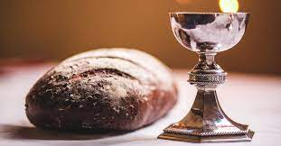

Please come forward to receive the Sacrament
or a blessing

Post Communion Prayers

Almighty and eternal God, you have revealed yourself as Father, Son and Holy Spirit, and live and reign in the perfect unity of love: hold us firm in this faith, that we may know you in all your ways and evermore rejoice in your eternal glory, who are three Persons yet one God, now and for ever.
All: Amen.

All: Almighty God, we thank you for feeding us with the body and blood of your Son Jesus Christ. Through him we offer you our souls and bodies to be a living sacrifice. Send us out in the power of your Spirit to live and work to your praise and glory. Amen.

Hymn

Ye watchers and ye holy ones
Bright Seraphs, Cherubim and Thrones
Raise the glad strain, Alleluya!
Cry out Dominions, Princedoms, Powers,
Virtues, Archangels, Angels’ choirs,
Alleluya, Alleluya, Alleluya
Alleluya, Alleluya!

O higher than the Cherubim,
More glorious than the Seraphim,
Lead their praises, Alleluya!
Thou Bearer of the eternal Word,
Most gracious, magnify the Lord,
Alleluya, Alleluya, Alleluya
Alleluya, Alleluya!

Respond, ye souls in endless rest,
Ye Patriarchs and Prophets blest,
Alleluya, Alleluya!
Ye holy Twelve, ye Martyrs strong.
All Saints triumphant, raise the song
Alleluya, Alleluya, Alleluya
Alleluya, Alleluya!

O friends, in gladness let us sing,
Supernal anthems echoing,
Alleluya, Alleluya!
To God the Father, God the Son,
And God the Spirit, Three in One,
Alleluya, Alleluya, Alleluya
Alleluya, Alleluya!

Athelstan Riley (1858-1945) (NEH478)

The Blessing

As you continue on your way, may you know that God goes before you. By the strength of his Spirit, share your faith with the uncertain; share your love with the unlovely; share your presence with the lonely; and share God with everyone, just as God has shared himself with you, in the unfading blessing of Jesus Christ, our Lord and Saviour. And the blessing of God almighty, the Father, the Son, and the Holy Spirit, be with you now and always.

All: Amen.

Go in peace to love and serve the Lord.
All: In the name of Christ. Amen.

Refreshments are served in the Lady Chapel and bring your own picnic across to the Rectory garden.
Please do join us!

To make an anonymous offertory donation to church,
please scan the QR below.
Thank you.



CCL760416

