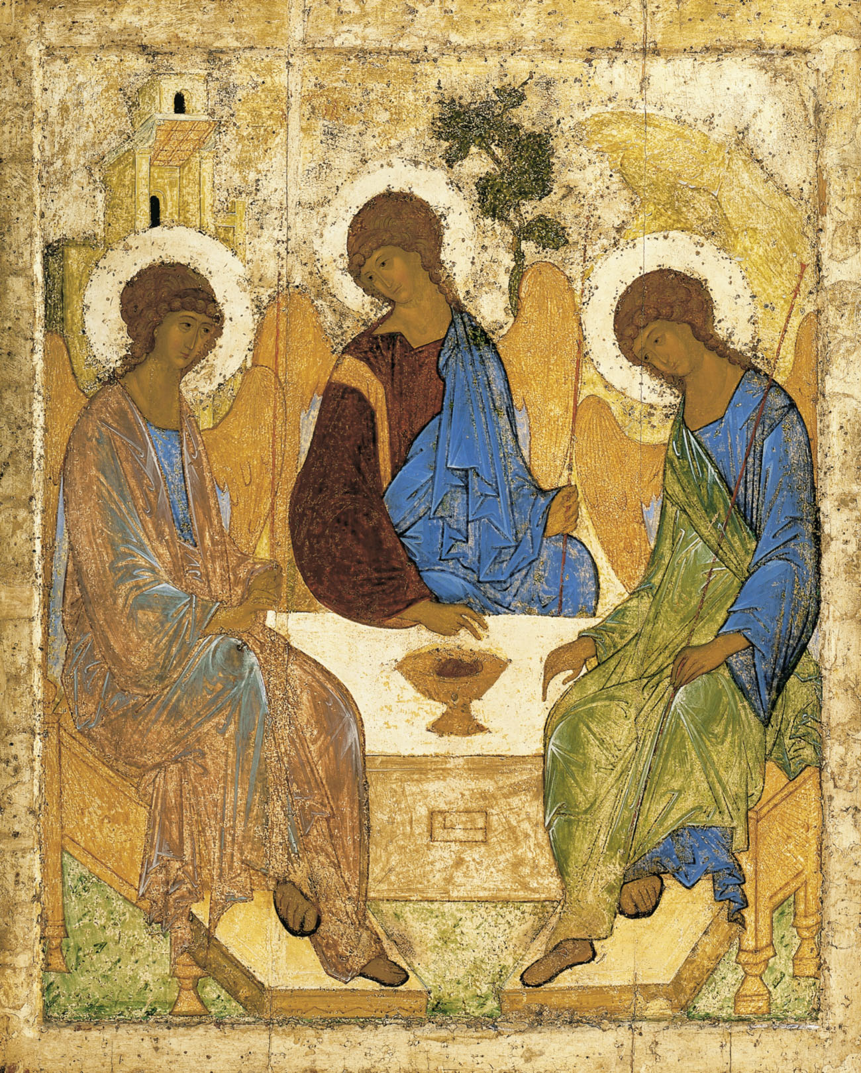
Holy Communion
at Holy Trinity Church, Jersey
Trinity Sunday
4th June 2023

Welcome and Preparation

The Lord be with you.
All And also with you.

As we rejoice in the gift of this new day, so may the light of your presence, O God, set our hearts on fire with love for you; now and for ever.
All Amen.

Processional Hymn

Go forth and tell!
O Church of God, awake!
God’s saving news to all the nations take:
proclaim Christ Jesus, Saviour, Lord and King,
that all the world his worthy praise may sing.

Go forth and tell!
God’s love embraces all;
he will in grace respond to all who call:
how shall they call if they have never heard
the gracious invitation of his word?

Go forth and tell!
where still the darkness lies;
in wealth or want, the sinner surely dies:
give us, O Lord, concern of heart and mind,
a love like Yours which cares for humankind.

Go forth and tell!
the doors are open wide:
share God’s good gifts - let no-one be denied;
live out your life as Christ your Lord shall choose,
Your ransomed pow’rs for his sole glory use.
Go forth and tell!
O church of God, arise!
Go in the strength which Christ your Lord supplies;
go till all nations his great name adore
and serve him, Lord and King, for evermore.
J E Seddon (1915-83) (HON164)

Please sit or kneel to pray
All: Almighty God, to whom all hearts are open, all desires known, and from
whom no secrets are hidden: cleanse the thoughts of our hearts by the
inspiration of your Holy Spirit, that we may perfectly love you, and worthily magnify your holy name; through Christ our Lord. Amen.

A Time of Confession

Let us come to the Lord, who is full of compassion, and acknowledge our transgressions in penitence and faith.

All Lord Jesus, we come to you in sorrow for our sins, and confess to you our weakness and unbelief. We have lived by our own strength, and not by the power of your resurrection. We have lived for this world alone, and doubted our home in heaven…

Choir: Lord have mercy, All: Lord have mercy
Choir: Christ have mercy, All: Christ have mercy
Choir: Lord have mercy, All: Lord have mercy

May the God of love and power forgive you and free you from your sins, heal and strengthen you by his Spirit, and raise you to new life in Christ our Lord.
All Amen.

(Please stand for the Gloria)
All Glory to God in the highest and peace to his people on earth. Lord
God, heavenly King, Almighty God and Father. We worship you we give you thanks we praise you for your glory. Lord Jesus Christ, Only Son of the Father, Lord God, Lamb of God, you take away the sin of the world; Have mercy on us. You are seated at the right hand of the Father; Receive our prayer. For you alone are the holy one, you alone are the Lord, you alone are the Most High, Jesus Christ with the Holy Spirit, In the glory of God the Father.
Ladies: Amen, Gents: Amen, Ladies: Amen, Gents: Amen, All: Amen.
The Collect

Almighty and everlasting God, you have given us your servants grace, by the confession of a true faith, to acknowledge the glory of the eternal Trinity and in the power of the divine majesty to worship the Unity; keep us steadfast in this faith, that we may evermore be defended from all adversities; through Jesus Christ your Son or Lord, who is alive and reigns with you, in the unity of the Holy Spirit, one God, now and for ever.
All: Amen.

The Word of God

Isaiah 40: 12-17, 27-end
Who has measured the waters in the hollow of his hand and marked off the heavens with a span, enclosed the dust of the earth in a measure, and weighed the mountains in scales and the hills in a balance?
Who has directed the spirit of the Lord, or as his counsellor has instructed him?
Whom did he consult for his enlightenment, and who taught him the path of justice?
Who taught him knowledge, and showed him the way of understanding?
Even the nations are like a drop from a bucket, and are accounted as dust on the scales; see, he takes up the isles like fine dust. Lebanon would not provide fuel enough, nor are its animals enough for a burnt-offering. All the nations are as nothing before him; they are accounted by him as less than nothing and emptiness.
Why do you say, O Jacob, and speak, O Israel, ‘My way is hidden from the Lord, and my right is disregarded by my God’? Have you not known? Have you not heard? The Lord is the everlasting God, the Creator of the ends of the earth. He does not faint or grow weary; his understanding is unsearchable. He gives power to the faint, and strengthens the powerless. Even youths will faint and be weary, and the young will fall exhausted; but those who wait for the Lord shall renew their strength, they shall mount up with wings like eagles, they shall run and not be weary, they shall walk and not faint.

This is the word of the Lord,
All: thanks be to God.

2 Corinthians 13: 11 – end

Finally, brothers and sisters, farewell. Put things in order, listen to my appeal, agree with one another, live in peace; and the God of love and peace will be with you. Greet one another with a holy kiss. All the saints greet you.
The grace of the Lord Jesus Christ, the love of God, and the communion of the Holy Spirit be with all of you.

This is the word of the Lord,
All: thanks be to God.

Hymn
Holy, holy, holy!
though the darkness hide thee
though the eye of sinful man
thy glory may not see
only thou art holy
there is none beside thee
perfect in power
in love, and purity.

Holy, holy, holy!
Lord God almighty!
All thy works shall praise thy name
in earth, and sky, and sea
holy, holy, holy!
merciful and mighty!
God in three persons
blessèd Trinity!

Reginald Heber (1783-1826) (NEH146)

Holy holy holy!
Lord God almighty!
Early in the morning
our song shall rise to thee
holy, holy, holy!
merciful and mighty!
God in three persons
blessèd Trinity!

Holy, holy, holy!
all the saints adore thee
casting down their golden crowns
around the glassy sea
cherubim and seraphim
falling down before thee
which wert, and art,
and evermore shall be.

Gospel Reading

Hear the Gospel of our Lord Jesus Christ according to Matthew:
All: Glory to you, O Lord.

Matthew 28: 16 - end

Now the eleven disciples went to Galilee, to the mountain to which Jesus had directed them. When they saw him, they worshipped him; but some doubted. And Jesus came and said to them, ‘All authority in heaven and on earth has been given to me. Go therefore and make disciples of all nations, baptizing them in the name of the Father and of the Son and of the Holy Spirit, and teaching them to obey everything that I have commanded you. And remember, I am with you always, to the end of the age.’

This is the Gospel of the Lord.
All: Praise to you, O Christ.

Reflections - The Rector

Affirmation of Faith

Brothers and sisters, I ask you to profess together the faith of the Church.

Do you believe and trust in God the Father, source of all being and life, the one for whom we exist?
All: I believe and trust in him.

Do you believe and trust in God the Son, who took our human nature, died for us and rose again?
All: I believe and trust in him.

Do you believe and trust in the Holy Spirit, who gives life to the people of God and makes Christ known in the world?
All: I believe and trust in him.

This is the faith of the Church.
All: This is our faith. We believe and trust in one God, Father, Son and Holy
Spirit. Amen.
Prayers of Intercession

All: … God to enfold us, Christ to uphold us, Spirit to keep us in heaven’s sight;
So may God grace us, heal and embrace us,
lead us through darkness into the light.

… Merciful Father,
All: accept these prayers for the sake of your Son, our Saviour Jesus Christ.
Amen.

The Peace

As children of the same heavenly Father, baptised by the Spirit into the family of God. Let us greet one another in the name of Jesus Christ.
The peace of the Lord be always with you
All: and also with you.

Offertory Hymn

How shall I sing that majesty
which angels do admire?
Let dust in dust and silence lie;
sing, sing, ye heavenly choir.
Thousands of thousands stand around
thy throne, O God most high;
ten thousand times ten thousand sound
thy praise; but who am I?
Thy brightness unto them appears,
whilst I thy footsteps trace;
a sound of God comes to my ears,
but they behold thy face.
I shall, I fear, be dark and cold,
with all my fire and light;
yet when thou dost accept their gold,
Lord, treasure up my mite.

Enlighten with faith's light my heart,
inflame it with love's fire;
then shall I sing and bear a part
with that celestial choir.
They sing, because thou art their Sun;
Lord, send a beam on me;
for where heaven is but once begun
there alleluias be.
How great a being, Lord, is thine,
which doth all beings keep!
Thy knowledge is the only line
to sound so vast a deep.
Thou art a sea without a shore,
a sun without a sphere;
thy time is now and evermore,
thy place is everywhere.
John Mason (c. 1645-1694) (SP280

Preparation of the Table

As the grain once scattered in the fields and the
grapes once dispersed on the hillside are now reunited on this table in bread and wine, so, Lord, may your whole Church soon be gathered together from the corners of the earth into your kingdom.
All: Amen.

Prayer of Consecration

The Lord is here.
All: His spirit is with us.
Lift up your hearts.
All: We lift them to the Lord.
Let us give thanks to the Lord our God.
All: It is right to give thanks and praise.

But chiefly are we bound to praise you because you raised him gloriously from the dead. For he is the true paschal lamb who was offered for us, and has taken away the sin of the world. By his death he has destroyed death, and by his rising to life again he has restored to us everlasting life. It is right to praise you, Father, Lord of all creation; in your love you made us for yourself. When we turned away you did not reject us, but came to
meet us in your Son.
All: You embraced a people as your children
and welcomed us to sit and eat with you.

In Christ you shared your life that we might live in him and he in us.
All: He opened his arms of love upon the cross
and made for all the perfect sacrifice for sin.

On the night before he was betrayed, at supper with his friends he took bread and gave you thanks; he broke it and gave it to them, saying: Take, eat; this is my body which is given for you; do this in remembrance of me.
All: Father, we do this in remembrance of him: his body is the bread of life.

At the end of supper taking the cup of wine, he gave you thanks, and said: Drink this all of you; this is my blood of the new covenant, which is shed for you for the forgiveness of sins; do this in remembrance of me.
All: Father; we do this in remembrance of him: his blood is shed for all.

As we proclaim his death and celebrate his rising in glory send your Holy Spirit that this bread and this wine may be to us the body and blood of your dear Son.
All: As we eat and drink these holy gifts make us one in Christ, our risen Lord.

With your whole Church throughout the world we offer you this sacrifice of praise and lift our voice to join the eternal song of heaven:

All: Holy, holy, holy Lord, God of power and might,
Heaven and earth are full of your glory, Hosanna in the highest.
Blessed is he who comes in the name of the Lord.
Hosanna, Hosanna, Hosanna in the highest.

Let us pray with confidence as our Saviour has taught us……
All: Our Father, who art in heaven, hallowed be thy name, thy kingdom
come, thy will be done on earth as it is in heaven. Give us this day our daily bread. And forgive us our trespasses as we forgive those who trespass against us. And lead us not into temptation, but deliver us from evil. For thine is the Kingdom, the power, and the glory, for ever and ever. Amen.

We break this bread to share in the body of Christ.
All: Though we are many, we are one body, because we all share in one
bread.

Choir Lamb of God you take away the sins of the world,
All Have mercy on us
Choir Lamb of God you take away the sins of the world,
All Have mercy on us
Choir Lamb of God you take away the sins of the world,
All Grant us peace.

Jesus is the Lamb of God who takes away the sin of the world. Blessed are those who are called to his supper.
All: Lord, I am not worthy to receive you, but only say the word,
and I shall be healed.

The Communion
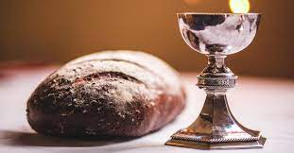

Please come forward to receive the Sacrament
or a blessing

Post Communion Prayers

Almighty and eternal God, you have revealed yourself as Father, Son and Holy Spirit, and live and reign in the perfect unity of love: hold us firm in this faith, that we may know you in all your ways and evermore rejoice in your eternal glory, who are three Persons yet one God, now and for ever.
All: Amen.

All: Almighty God, we thank you for feeding us with the body and blood of your Son Jesus Christ. Through him we offer you our souls and bodies to be a living sacrifice. Send us out in the power of your Spirit to live and work to your praise and glory. Amen.

The Blessing

As you continue on your way, may you know that God goes before you. By the strength of his Spirit, share your faith with the uncertain; share your love with the unlovely; share your presence with the lonely; and share God with everyone, just as God has shared himself with you, in the unfading blessing of Jesus Christ, our Lord and Saviour. And the blessing of God almighty, the Father, the Son, and the Holy Spirit, be with you now and always.
All: Amen.

Hymn

Ye watchers and ye holy ones
Bright Seraphs, Cherubim and Thrones
Raise the glad strain, Alleluya!
Cry out Dominions, Princedoms, Powers,
Virtues, Archangels, Angels’ choirs,

Alleluya, Alleluya, Alleluya
Alleluya, Alleluya!

O higher than the Cherubim,
More glorious than the Seraphim,
Lead their praises, Alleluya!
Thou Bearer of the eternal Word,
Most gracious, magnify the Lord,

Respond, ye souls in endless rest,
Ye Patriarchs and Prophets blest,
Alleluya, Alleluya!
Ye holy Twelve, ye Martyrs strong.
All Saints triumphant, raise the song

O friends, in gladness let us sing,
Supernal anthems echoing,
Alleluya, Alleluya!
To God the Father, God the Son,
And God the Spirit, Three in One,

Athelstan Riley (1858-1945) (NEH478)

Go in peace to love and serve the Lord.
All: In the name of Christ. Amen.

Refreshments are served in the Lady Chapel.
Please do join us!

To make an anonymous offertory donation to church,
please scan the QR below.
Thank you.

CCL760416

