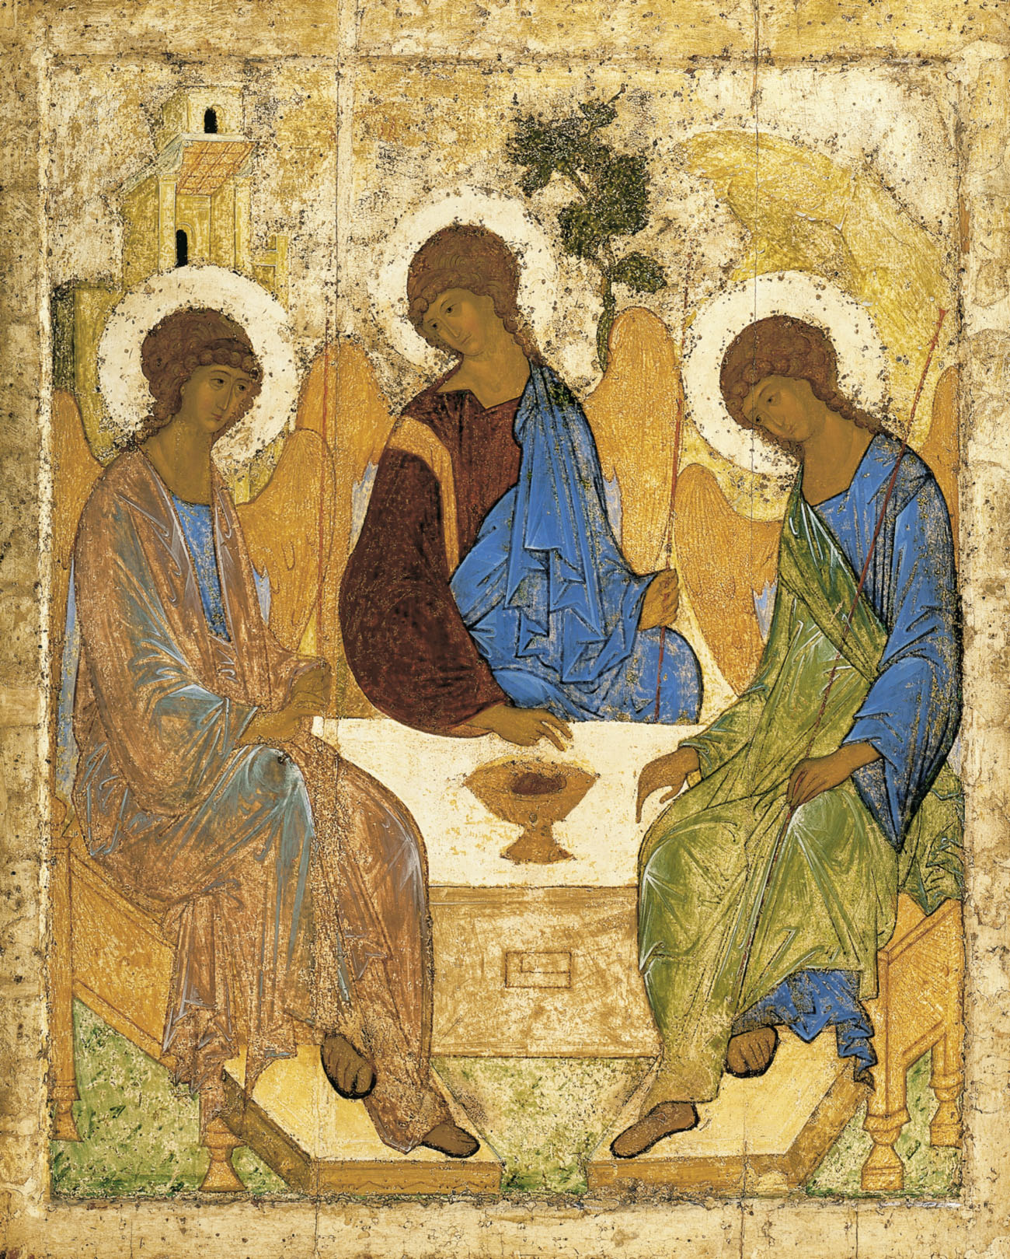

Holy Trinity Church, Jersey
Written Reports for the Annual General Meeting

Sunday 1st May, 2022

In recent years the Annual General Meeting of our Church has taken place immediately following the 11 am service, increasing the number of those able to attend, but bringing a time pressure to the agenda as people have needed to engage in the rest of their day. The purpose of this leaflet is to give you the opportunity to read and consider reports on the life of your church at your leisure in advance of the meeting.
The Rector and the Treasurer will give reports in person to the meeting on Sunday 1st May. Copies of the accounts will also be available and thereafter online.

Trinity Parish Church, Rector’s Report AGM 2022
As has become our custom over the years, I would like to proffer my annual report now, and then immediately following the service, we can conduct the more formal aspects of business with further brief reports from the churchwardens and other officers.
First and foremost, in the context of a hugely challenging year I want to say thank you to our two Churchwardens. Both present and very much hands on at virtually every morning service, ensuring the welcome, the adherence to covid rules, now thankfully a thing of the past, and the good order of what we do has been sustained unstintingly. And moreover, meeting with me regularly so that together we have been able to review and to plot our emergence from some two years of pandemic, also drawing on the wisdom of Nick and the other members of the Advisory Group. Thank you.
Even with the lifting of all regulations, bar our continued following of advice to not share the common cup, we are not ‘back to normal’, we are all a little bit older, a few have got out of the habit of attending on a Sunday, so it can seem that there are fewer of us worshipping together. However, the continued use of Zoom has allowed a goodly number of people, both local and from further afield to be part of our community.
The irony is not lost to me that it took over a year for us to finally fine tune our use of technology and improve the quality, by which time most people were back in person. However, I particularly want to thank Daniel, Gill, Angela and Andrew for running of the system, and Peter Colback for his technical support. Twelve or fifteen people typically join the 11 am Sunday service through Zoom each week.
To those behind the scenes I want to say thank you - namely to Peter Colback who has provided no end of IT support to us, and also to our Administrator, Amy, who works both in the office and from home to provide me and the Wardens with administrative help, and does so wonderfully graciously, as those who have occasion to speak to her on the phone will know.
And my thanks to you as members of the congregation who by your presence, in all your rich diversity of personality, make this the most wonderful congregation and each of you are treasured fellow pilgrims on the way. Thank you.
Like you, my experience of worship in Trinity is enhanced by our wonderful Readers, Helen, Angela and Fleur, who have fed us richly with their opening of God’s word for us, on screen, and here in the building.
These last few months it has been fabulous to have our wonderful church choir leading us in singing and the liturgy, all under Nick’s wonderful and tireless direction. Thank you!
Last year we noted the growth of the Tuesday evening congregation, now regularly some fifteen or sixteen regulars, either in person or online, and that fellowship has continued and strengthened. Similarly, we are intent on offering more mid-week worship services, and Angela is looking to provide a Wednesday evening reflective service on a bi-monthly basis going forward as part of her Lay Ministry amongst us, again, a combination of in-person and online.
Our younger families and their children were not to be put off by the challenges of the last couple of years. As a group they have truly thrived, mostly meeting outside they have been fortunate with the weather. Their own report is included in the leaflet, which I commend to you, and I very much want to thank Chris Bray and Pam Warr and the wider team without whom these things simply wouldn’t happen. Moreover, I am delighted that Sarah Prosser is coming on board to lead and grow this ministry. She will be building on some great work, and does so as someone who greew up as part of this church and has been attending the children and family sessions as a parent.
We are hugely grateful to the Connétable, Procureurs and Municipality of Trinity for their ongoing support and care for their Parish Church. With that in mind there will be some redecoration of the paint work both outside on the building, though it won’t have escaped your notice that the awaited redecoration of the North transept has not happened. The handrail at the chancel step was installed but the design did not successfully translate into what we really wanted. A simpler rail will be installed shortly. Similarly, the quote for adjusting the steps and corresponding banister of the pulpit was revised upward to four or five thousand pounds. We are awaiting a further comparative quote, but may need to think again on that project.
I also want to thank the work the Trinity Honorary Police, especially their calming of traffic around funerals.
Sadly, amongst the many funerals we have held here and at the Crematorium, we bade farewell and thank you to some of our own fellowship, faces we miss still from this place. Amongst them, James Jenkin, Margaret Jeffrey, Liz Reynolds, Roger Mitchell, Jean Powell, John Routier, Christine Cudlipp, and Kate Tettmar. They continue in our memories and their families in our hearts.
On the flip side we rejoice with numerous of the young families associated with our church and there are familiar names amongst my baptism bookings list, as the circle of life turns…
Most importantly, as we reflect on this last year and look to the year ahead, we need to focus afresh on the main thing, our reason for being and our audacity to call ourselves a church. So, what is the main thing? Turning up on a Sunday? Helping on a roster? Putting collection money in the plate? Well, these things are most useful. However, when Jesus was asked by a lawyer what the most important thing was, he replied.
‘Love God with all your heart, and with all your soul, and with all your mind, and with all your strength, and love your neighbour as yourself.’
That’s the main thing – and if our lives and our shared endeavours as church, if all the individual actions and volunteering don’t reflect that love, in our worship and in our prayers, in our building up, our inclusion, our grace of one another - our neighbour, near and far, then we are falling short of the main thing. Since in the words of Bishop Michael Curry – ‘If it’s not about love, it is not about God’.
You will have heard me mention ‘inclusion’ a moment ago, and a month or so ago I spoke in a sermon of the Inclusive Church Movement, and my recommendation, supported unanimously by those Advisory Group members who shared in discussion on the matter, that we join this movement as a member church. After the service today (1st May), in the business part of the meeting, I shall make such a proposal, not as a mechanism to grandstand on any particular issue of inclusion, but as a means of holding ourselves to account going forward, rather than assuming we are inclusive when in reality we may not be…
Inevitably, there are financial responsibilities and costs that come with the life of the church, and first and foremost I want to say thank you to all of you for your support and generosity, and also to Aynslie, Peter Routier and Andrew Le Brun who through their skill and experience keep our finances in order. Thank you.
Lastly, I just want to say thank you to Fran, as I have often said, she is my all, and without her I wouldn’t, couldn’t fulfil my role.
Thank you to all.

Churchwardens’ Report – Aynslie Le Brun and Jo Dawson
We are pleased that 2021-22 has seen a return to church with very limited restrictions. It is good to feel like “church” again.
We would like to thank Nick Cabot for providing music at the 8.30, 11.00 and 6pm services. It is also lovely to have the choir singing in church once again.
Thanks also go to our band of welcomers who assist every Sunday. We would also like to thank Angela, Fleur and Helen for their inspiring addresses and all who lead our many different services. We must also thank our intercessors, readers and those who help with Zoom. It really does help keep the house-bound in touch with church and is much appreciated. There are also others who provide coffee after the services and our flower arrangers who make the church look so beautiful, particularly at festivals.
It is encouraging to see the number of weddings and baptisms taking place in church this year. Sadly, we have also lost a number of our faithful congregation and they are much missed.
We appreciate the work of all those involved in children’s work and look forward to welcoming Sarah Prosser (Pexton) as our new Children’s and Families Co-Ordinator.
We would also like to thank Amy Britton, our administrator, and Anna Woodman, who prepares the monthly newsletter.
We continue with ongoing maintenance work in the church, the north transept being the next project. You will have noticed that we have switched the vestries over, due to a problem with the floor in what was the Rector’s vestry. We are still working on a solution to the handrail at the Chancel Step and also what work can be done on the pulpit. Another major project will be the church steeple, which is looking rather grey.
Last, but by no means least, we would like to thank our Rector, Geoff, for his leadership and love and support he shows to us all, and also Fran, quietly helping in the background, but no less essential to the running of the church in Trinity.

Deanery Synod – Aynslie Le Brun
I am pleased to say that it has been a fairly uneventful year for the Deanery Synod.
We welcomed our new Synod after the Triennial elections last summer. I was re-elected as Finance Chair and David Smith has taken over the role of Lay Chair from Sir Philip Bailhache, who stood down this year. Paul Matthams is our General Synod representative. We have yet to elect representatives to the Salisbury Synod until we formally become part of the Diocese.
Our revised Canon Laws were approved by the States in March. Amongst other matters, this allows us to join Salisbury Diocese and accepts women bishops. There are still some final steps before we will be welcomed into the Diocese as a special service later in the year.
You will have seen in the press that the Very Reverend Stephen Lake is the new Bishop-elect of Salisbury and we are looking forward to welcoming him to the Island later in the year at an Island-wide service.
The Island’s clergy, together with their colleagues from Guernsey recently went on a trip to Salisbury to familiarise themselves with the Cathedral team. I know that they felt welcomed and supported and this is likely to become a biennial event.
On the finances, we set a budget of £968,000 for 2021. After some unexpected savings, it was decided to offer the parishes a rebate of £1,000 to cover extra IT and Covid-related expenses and a further amount on the actual parish share. We, at Trinity, received £1,000 against IT and Covid expenses and were offered a £3,000 rebate on our share, but decided not to claim the amount and asked that it be used to assist churches that were struggling to pay their share.
The Deanery has budgeted for expenditure of £957,000 for 2022 and a small surplus of £30,000. Trinity’s share has reduced from £76,000 to £73,000 for 2022.
The Channel Islands have also carried out a review of clergy stipends, last reviewed 5 years ago. It was agreed to retain the uplift of 22.4% for Channel Island clergy over the UK National Benchmark. The clergy received a pay increase of 1% for 2022-23. The Church of England pension fund seems to have made a surplus, so we are hoping that contributions to the clergy pension scheme will reduce from April.

Readers’ Report – Helen Hamilton
Since Fleur wrote the last report, Angela and Fleur have become fully fledged Lay Readers with a good few years’ experience under their belts and I very much appreciate their support. Apparently, we have now been rechristened ‘Licensed Lay Ministers’, and indeed Geoff gives us much license to go about our own style of preaching. He is generous in his allocation and his encouragement. Encouragement is a word that also typifies you the congregation. You are of course at liberty to disagree with something we may say and please feel free to voice that; for I know that it will be said gently. The overwhelming feeling that comes back to me is one of kindness and solidarity; and goodness knows, in these uncertain times, with Geoff leading us so ably through an unprecedented pandemic and now this dreadful war, we need kindness and solidarity. This Lay Readership thing is a two-way street, so thank you from the bottom of my heart for that.
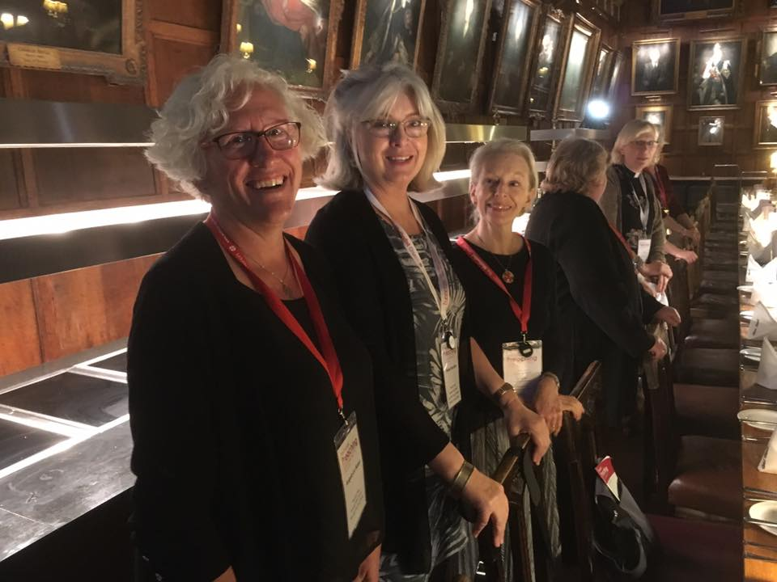

Fleur adds: Seasoned Reader-watchers in the congregation will know that Angela and I braved the selection process, the studying, the onerous exam-writing, and the travelling together. We endured a nail-biting final assessment together, and at that point, my nails were considerably shorter than Angela’s. Finally, we were licensed twice over: once in Canterbury Cathedral and once in the bosom of our church and actual families.
Since then, we have continued pretty much in step, until recently. Having settled into our roles, Angela discerned that she was called to spend more of her time and talents on devising and leading services. This increases the opportunities for experiencing worship in different ways, not only for the regular members of the congregation, but also for those who are not drawn to the standard Sunday services. Other commitments may get in the way, or maybe a full hour of stand up, sit down, sing now, pray now, is just too much to cope with. So we think Angela’s creative spirit will open a new door to some of us and some of them.
The upshot is that Angela will do a bit less preaching and Geoff will pick up the slack with back-up from Helen and me. We continue to work as a team, which we enjoy, and we hope you enjoy the fruits of our collaboration.
Church Link to the Anglican Church in Goma in the Democratic Republic of Congo –

Unfortunately, since the death of Bishop Desire some two years ago, our connections with our link Diocese has been rather quiet as they patiently wait for the appointment of a new Bishop for the Diocese of Goma. In addition to our prayers we have been able to send out some funds via CMS-Ireland which are always gratefully received and acknowledged. Last year we also contributed to acquisition of land for the extension of a primary school in Goma and look forward to hearing how the building work is progressing in due course.

Trinity Church Choir – Nick Cabot MBE
Life has been especially difficult for the choir because, as you all know, singing has become a ‘dangerous’ activity over the past two years.

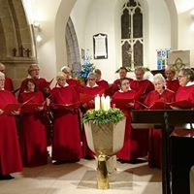
After a break which lasted a year the choir re-commenced it’s practices and singing at services during May 2021 with joy and enthusiasm. We are a smaller number than before. Increasing health difficulties for some of us exacerbated by Covid have led to Judy Leighton retiring. Pam Cabot despite a variety of health issues keeping her away for much of the year has managed to return to us. Most of us have been beset by family issues brought on by Covid but we have managed to play our part in all the usual services over the past year.

Through good practice and luck none of us caught Covid until just last month during which six of us succumbed and are still recovering. From what we have been able to tell none of us gave it to one another – we caught it from outside sources.

The past year will be remembered for the number of funerals and the weight of responsibility and sadness which is borne by all those involved – the families and all of us here at church when we lose friends whom we have known and shared laughter with for many years. There have been so many long-term members of our congregation who have died during the past year that it would be invidious to mention any by name. From the choir we have lost John Routier, Roger Mitchell and, tragically, Margaret Jefferies who was taken well before ‘her time’. We have shared so much music making, fun and laughter together that we cannot easily leave these friends behind and it still feels as if they are with us – we will not forget them.

On a more positive note and by complete co-incidence we have had two prospective altos and two prospective sopranos ask to join us. They have started to attend practices and, hopefully, it will not be too long before you will see them at services. We still need more recruits – especially some more basses.

Holy Trinity Church remains very lucky that it has such a group of singers who give up a large amount of time from their lives to support the worship in our church. May I take this opportunity to thank them, most sincerely, for their patience and forbearance in putting up with me for yet another year.

Safeguarding – Gill John
From a parish safeguarding perspective the last year has been mercifully quiet. We continue to encourage all of our youth workers to get up to date DBS checks and new online training will soon be forwarded to them to complete when they are able. Unfortunately face to face training has had to take a backseat during the pandemic but I would encourage anyone in the congregation who feels they wish to complete the foundation course online to contact me and I would be very happy to forward the link.
I have continued to be involved as the Jersey representative in the historic case review across the Channel Islands and a report has now been forwarded to the national body as a contribution to their response expected later this year.
As ever, I remind you that safeguarding those in our congregation who may be vulnerable for any reason, at any time, is the collective responsibility of all of us. If you have any concerns about anyone please speak to Geoff or myself or contact us via the email addresses on the church website.

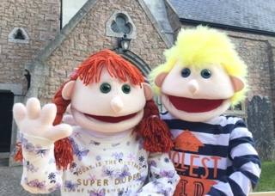
Children’s Ministry – Chris Bray
Despite the many constraints of this past year we, the team of loyal volunteers; Pam W, Pam K, Anthea, Cheryl, Laura, Fran, Sarah, Sian, David and Ruth Hayward and others have managed to maintain and progress the Children’s Ministry here at Trinity.

In the main, meetings were held successfully out in the open in the Rectory gardens, and we were generally blessed with suitable weather to be outside. Each session had a specific focus and was usually concluded with a ‘take away’ craft pack and suitable refreshments. We have built and maintained a solid core of regular families whose attendance has varied according to their wider commitments, and who have developed strong bonds of friendship and fellowship.

There were opportunities for Christian bible stories led sometimes by Denzil or Gladys, with the storytelling often offered in a visual and interactive format; an example of this being the Prodigal Son Returns. We also enjoyed potato planting in the Rectory Garden’s raised bed, followed by tractor rides around the grounds. There was also a celebration of St Valentine’s Day with a starring role taken by the jailor’s daughter, Plough Sunday, a ‘Beach Clean’ and the young ones and their parents also made many, many paper angels for last Christmas’ display.

Thankfully we were able this year to run the traditional Sunday School Outing with vintage lorry rides around the island, and a scrumptious tea and bouncy castle to round off.

Christmas was focused around a walking Nativity, held again in the Rectory gardens, with visiting shepherds, kings and culminating in a stable scene in a Rectory garage.

The year has turned full circle and our potato planting activity has come around again. This time participants were able to take away their own made-up pots – I wonder what the results will be! Lastly, we recently took part in a successful beach clean down at Rozel.

In conclusion, we would like to say thank you to everyone for their support of our Children’s Ministry in a huge variety of different ways, and we look forward to welcoming Mrs Sarah Prosser into the leadership team in her new role as Children’s and Families’ Co-Ordinator.

Finance report – 2021, from Andrew Le Brun, Treasurer

Two congregational bank accounts are held by the churchwardens: the collections account; and the fundraising account. Financial statements are prepared for both.

All giving is banked though the collections account. In the year ended 31 December 2021, income from giving and other (non-fund raising) activities increased by around £12,000 to just over £92,000. This was because of increased giving through standing orders and higher tax refunds (linked to covenants and donations of £50 or more), which were partly set off by reduced plate collections (still affected by COVID), envelope giving (now largely discontinued) and gift day donations. Standing orders were substantially higher than normal due to two large one-off offerings.

All day-to-day expenses are paid from the collections account. The largest expense (£75,000) is the payment of parish share to the Deanery and the amount was the same as in 2020. Other main expenses include salaries and social security (for our administrator), printing costs, and service costs. The latter two increased as services returned to something approaching normal in 2021. Overall, expenditure increased by around 6% in 2021 to just over £102,000.

The collections account is also used to pay for investment in new equipment. Capital costs in 2021 include an investment to better support the continued use of Zoom.

Overall, expenditure exceeded income by around £10,000. This loss was absorbed by large reserves, which fell to just over £100,000.

Funds available on the fundraising account have increased to just over £9,600 because of one large donation and quarterly commissions received from easyfundraising.com, linked to purchases made by the congregation on that website.

