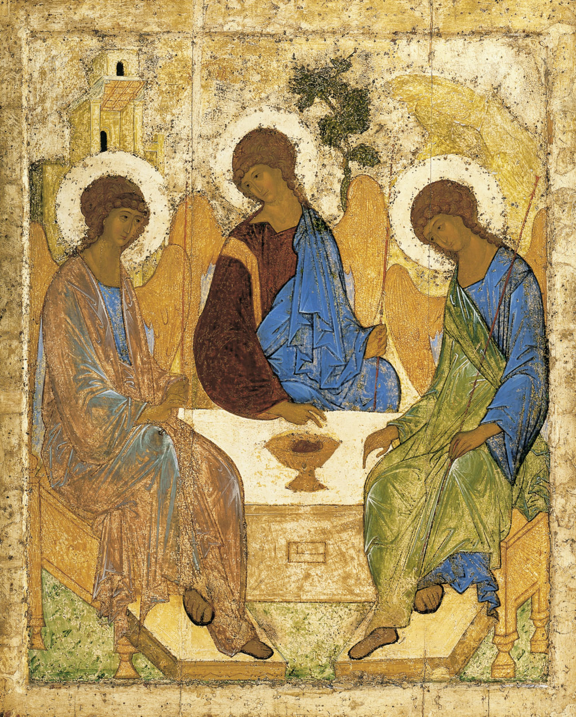
Holy Communion
Trinity Parish Church, Jersey
5th Sunday of Easter
28th April 2024

Welcome and Preparation

The Lord be with you.
All And also with you.

As we rejoice in the gift of this new day, so may the light of your presence, O God, set our hearts on fire with love for you; now and for ever.
All Amen.

Processional Hymn

I, the Lord of sea and sky
I have heard my people cry
All who dwell in dark and sin
my hand will save
I who made the stars of night
I will make their darkness bright
Who will bear my light to them?
Whom shall I send?

Here I am, Lord. Is it I Lord?
I have heard you calling in the night
I will go, Lord, if you lead me
I will hold your people in my heart.

I, the Lord of snow and rain
I have borne my people’s pain
I have wept for love of them
They turn away
I will break their hearts of stone
give them hearts of love alone
I will speak my word to them
Whom shall I send?

I, the Lord of wind and flame
I will tend the poor and lame
I will set a feast for them
My hand will save
Finest bread I will provide
till their hearts be satisfied
I will give my life to them
Whom shall I send?

Dan Schutte (b. 1947) (SP158)

Prayer of Preparation

All Almighty God, unto whom all hearts be open, all desires known, and from whom no secrets are hidden: cleanse the thoughts of our hearts by the inspiration of your Holy Spirit, that we may perfectly love you, and worthily magnify your holy name; through Christ our Lord. Amen.

A Time of Confession

Let us come to the Lord, who is full of compassion, and acknowledge our transgressions in penitence and faith.

All Lord Jesus, we come to you in sorrow for our sins, and confess to you our weakness and unbelief. We have lived by our own strength, and not by the power of your resurrection. We have lived for this world alone, and doubted our home in heaven…

Choir: Lord have mercy, All: Lord have mercy
Choir: Christ have mercy, All: Christ have mercy
Choir: Lord have mercy, All: Lord have mercy

May the God of love and power forgive you and free you from your sins, heal and strengthen you by his Spirit, and raise you to new life in Christ our Lord.
All Amen.

The Gloria - Please stand

All Glory to God in the highest and peace to his people on earth. Lord
God, heavenly King, Almighty God and Father. We worship you we give you thanks we praise you for your glory. Lord Jesus Christ, Only Son of the Father, Lord God, Lamb of God, you take away the sin of the world; Have mercy on us. You are seated at the right hand of the Father; Receive our prayer. For you alone are the holy one, you alone are the Lord, you alone are the Most High, Jesus Christ with the Holy Spirit, In the glory of God the Father.

Ladies: Amen, Gents: Amen, Ladies: Amen, Gents: Amen, All: Amen.

The Collect

Almighty God, who through your only-begotten Son Jesus Christ have overcome death and opened to us the gate of everlasting life: grant that, as by your grace going before us you put into our minds good desires, so by your continual help we may bring them to good effect; through Jesus Christ our risen Lord, who is alive and reigns with you, in the unity of the Holy Spirit, one God, now and for ever. Amen.

The Word of God

Acts 8. 26 - end

Then an angel of the Lord said to Philip, ‘Get up and go towards the south to the road that goes down from Jerusalem to Gaza.’ (This is a wilderness road.) So he got up and went. Now there was an Ethiopian eunuch, a court official of the Candace, queen of the Ethiopians, in charge of her entire treasury. He had come to Jerusalem to worship and was returning home; seated in his chariot, he was reading the prophet Isaiah. Then the Spirit said to Philip, ‘Go over to this chariot and join it.’ So Philip ran up to it and heard him reading the prophet Isaiah. He asked, ‘Do you understand what you are reading?’ He replied, ‘How can I, unless someone guides me?’ And he invited Philip to get in and sit beside him. Now the passage of the scripture that he was reading was this:
‘Like a sheep he was led to the slaughter, and like a lamb silent before its shearer, so he does not open his mouth. In his humiliation justice was denied him. Who can describe his generation? For his life is taken away from the earth.’ The eunuch asked Philip, ‘About whom, may I ask you, does the prophet say this, about himself or about someone else?’ Then Philip began to speak, and starting with this scripture, he proclaimed to him the good news about Jesus. As they were going along the road, they came to some water; and the eunuch said, ‘Look, here is water! What is to prevent me from being baptized?’ He commanded the chariot to stop, and both of them, Philip and the eunuch, went down into the water, and Philip baptized him. When they came up out of the water, the Spirit of the Lord snatched Philip away; the eunuch saw him no more, and went on his way rejoicing. But Philip found himself at Azotus, and as he was passing through the region, he proclaimed the good news to all the towns until he came to Caesarea.

This is the word of the Lord,
All Thanks be to God.

1 John 4. 7 - end
Beloved, let us love one another, because love is from God; everyone who loves is born of God and knows God. Whoever does not love does not know God, for God is love. God’s love was revealed among us in this way: God sent his only Son into the world so that we might live through him. In this is love, not that we loved God but that he loved us and sent his Son to be the atoning sacrifice for our sins. Beloved, since God loved us so much, we also ought to love one another. No one has ever seen God; if we love one another, God lives in us, and his love is perfected in us.
By this we know that we abide in him and he in us, because he has given us of his Spirit. And we have seen and do testify that the Father has sent his Son as the Saviour of the world. God abides in those who confess that Jesus is the Son of God, and they abide in God. So we have known and believe the love that God has for us.
God is love, and those who abide in love abide in God, and God abides in them. Love has been perfected among us in this: that we may have boldness on the day of judgement, because as he is, so are we in this world. There is no fear in love, but perfect love casts out fear; for fear has to do with punishment, and whoever fears has not reached perfection in love. We love because he first loved us. Those who say, ‘I love God’, and hate their brothers or sisters, are liars; for those who do not love a brother or sister whom they have seen, cannot love God whom they have not seen. The commandment we have from him is this: those who love God must love their brothers and sisters also.

This is the word of the Lord,
All Thanks be to God.

Hymn
The Word, like rain or snow,
has come down from above,
and now reveals to all
God’s purposes of love;
the Word made flesh, once dead, now lives,
new life to all he freely gives.

The myrtle for the briar,
the cypress for the thorn,
shall rise to tell the world
of its awaking dawn.
Jesus, the Life, the Truth, the Way,
has ushered in God’s great new day.

You shall go out with joy
and come again in peace;
the mountains and the hills
shall sing and never cease;
the Son of God is ris’n again,
his love has conquered death’s domain.

The trees in every field
shall clap their hands, and say
‘Come shout aloud, and help
us celebrate this day!’
Jesus, the King, has burst the grave,
and lives once more to heal and save.

N.T.Wright (b.1948) (SP82)
Based on Isaiah 55. 10-13

Gospel Reading

Hear the Gospel of our Lord Jesus Christ according to John:
All Glory to you O Lord.

John 15. 1 - 8

‘I am the true vine, and my Father is the vine-grower. He removes every branch in me that bears no fruit. Every branch that bears fruit he prunes to make it bear more fruit. You have already been cleansed by the word that I have spoken to you. Abide in me as I abide in you. Just as the branch cannot bear fruit by itself unless it abides in the vine, neither can you unless you abide in me. I am the vine, you are the branches. Those who abide in me and I in them bear much fruit, because apart from me you can do nothing. Whoever does not abide in me is thrown away like a branch and withers; such branches are gathered, thrown into the fire, and burned. If you abide in me, and my words abide in you, ask for whatever you wish, and it will be done for you. My Father is glorified by this, that you bear much fruit and become my disciples.

This is the Gospel of the Lord,
All Praise to you, O Christ.

Reflections – Fleur Benest

Affirmation of Faith

Brothers and sisters, I ask you to profess together the faith of the Church.

Do you believe and trust in God the Father, source of all being and life, the one for whom we exist?
All: I believe and trust in him.
Do you believe and trust in God the Son, who took our human nature, died for us and rose again?
All: I believe and trust in him.
Do you believe and trust in the Holy Spirit, who gives life to the people of God and makes Christ known in the world?
All: I believe and trust in him.

This is the faith of the Church.
All: This is our faith. We believe and trust in one God, Father, Son and Holy
Spirit. Amen.

Prayers of Intercession

The response is:
Lord, in your mercy, All hear our prayer.

Merciful Father
All accept these prayers for the sake of your Son, our Saviour Jesus Christ.
Amen.

The Peace

The risen Christ came and stood among his disciples and said, ‘Peace be with you.’ Then were they glad when they saw the Lord. Alleluia.
The peace of the Lord be with you.
All And also with you.

Offertory Hymn

I am the Light whose brightness shines
on every pilgrim’s way,
and brings to evil’s darkest place
the glorious light of day.

I am the Bread, God’s gift from heaven,
sent down to satisfy
that hunger which cries out for food;
who eats shall never die.

I am the Vine whose branches grow
united in one root;
who dwell in me, and I in them,
shall live and bear much fruit.

I am the Resurrection life,
the power of God whereby
whoever truly trusts in me
shall live and never die.

I am the Way, the Truth, the Life,
and truth shall set you free
to seek and find the way of life
and live that life in me.
Robert Willis (b. 1947)(SP281)

Preparation of the Table

Blessed are you, Lord God of all creation; through your goodness we have this bread to set before you, which earth has given and human hands have made. It will become for us the bread of life.
All Blessed be God forever.
Blessed are you, Lord God of all creation; through your goodness we have this wine to set before you, fruit of the vine and work of human hands.
It will become for us the cup of salvation.
All Blessed be God forever.

Prayer of Consecration

The Lord is here. All His Spirit is with us.
Lift up your hearts. All We lift them to the Lord.
Let us give thanks to the Lord our God.
All It is right to give thanks and praise.

Blessed are you Lord God, our light and our salvation; to you be glory and praise for ever. From the beginning you have created all things and all your works echo the silent music of your praise. In the fullness of time you made us in your image, the crown of all creation.

You give us breath and speech, that with angels and archangels and all the powers of heaven we may find a voice to sing your praise:
All Holy, holy, holy Lord, God of power and might,
Heaven and earth are full of your glory, Hosanna in the highest.
Blessed is he who comes in the name of the Lord.
Hosanna, Hosanna, Hosanna in the highest.

How wonderful the work of your hands, O Lord. As a mother tenderly gathers her children, you embraced a people as your own. When they turned away and rebelled your love remained steadfast. From them you raised up Jesus our Saviour, born of Mary, to be the living bread, in whom all our hungers are satisfied. He offered his life for sinners, and with a love stronger than death he opened wide his arms on the cross.

On the night before he died, he came to supper with his friends and, taking bread, he gave you thanks. He broke it and gave it to them, saying: Take eat;
this is my body, which is given for you; do this in remembrance of me.

At the end of supper, taking the cup of wine, he gave you thanks, and said: Drink this, all of you; this is my blood of the new covenant, which is shed for you and for many for the forgiveness of sins. Do this, as often as you drink it, in remembrance of me.
Great is the mystery of faith:
All Christ has died, Christ is risen, Christ will come again.

Father, we plead with confidence his sacrifice made once for all upon the cross; we remember his dying and rising in glory, and we rejoice that he intercedes for us at your right hand.

Pour out your Holy Spirit as we bring before you these gifts of your creation; may they be for us the body and blood of your dear Son. As we eat and drink these holy things in your presence, form us in the likeness of Christ, and build us into a living temple to your glory.
Bring us at the last with all the saints to the vision of that eternal splendour for which you have created us; through Jesus Christ, our Lord, by whom, with whom and in whom, with all who stand before you in earth and heaven, we worship you, Father almighty, in songs of everlasting praise, saying:
All Blessing and honour and glory and power be yours for ever and ever. Amen.

Let us pray with confidence as our Saviour has taught us:
All Our Father; who art in heaven, hallowed be thy name; thy kingdom come;
thy will be done; on earth as it is in heaven. Give us this day our daily bread. And forgive us our trespasses, as we forgive those who trespass against us. And lead us not into temptation; but deliver us from evil.
For thine is the kingdom, the power and the glory, for ever and ever. Amen.

We break this bread to share in the body of Christ.
All Though we are many, we are one body, because we all share in one bread.

Choir Lamb of God you take away the sins of the world,
All Have mercy on us
Choir Lamb of God you take away the sins of the world,
All Have mercy on us
Choir Lamb of God you take away the sins of the world,
All Grant us peace.

Jesus is the Lamb of God who takes away the sin of the world.
Blessed are those who are called to his supper:
All Lord, I am not worthy to receive you, but only say the word, and I shall
be healed.

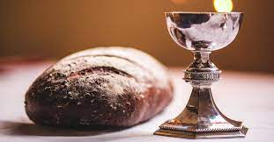
The Communion

Please come forward to receive bread or a blessing.

Prayer after Communion

Eternal God, whose Son Jesus Christ is the way, the truth and the life: grant us to walk in his way, to rejoice in his truth, and to share his risen life; who is alive and reigns, now and for ever.
Amen.

All Father of all, we give you thanks and praise, that when we were still far
off you met us in your Son and brought us home. Dying and living, he declared your love, gave us grace, and opened the gate of glory. May we who share Christ’s body live his risen life; we who drink his cup bring life to others; we whom the Spirit lights give light to the world. Keep us firm in the hope you have set before us, so we and all your children shall be free, and the whole earth live to praise your name; through Christ our Lord. Amen.

The Blessing

God the Father, by whose love Christ was raised from the dead, open to you who believe the gates of everlasting life. God the Son, who in bursting from the grave has won a glorious victory, give you joy as you share the Easter faith. God the Holy Spirit, who filled the disciples with the life of the risen Lord, empower you and fill you with Christ’s peace.
And the blessing of God almighty, the Father, the Son and the Holy Spirit, be amongst you and remain with you always.
Amen.
Hymn
Come, almighty to deliver,
let us all thy life receive;
suddenly return, and never,
never more thy temples leave.
Thee we would be always blessing,
serve thee as thy hosts above;
pray, and praise thee, without ceasing,
glory in thy perfect love.

Love divine, all loves excelling,
joy of heaven, to earth come down,
fix in us thy humble dwelling,
all thy faithful mercies crown.
Jesu, thou art all compassion,
pure unbounded love thou art;
visit us with thy salvation,
enter every trembling heart.

Finish then thy new creation:
pure and spotless let us be;
let us see thy great salvation,
perfectly restored in thee;
changed from glory into glory,
till in heaven we take our place,
till we cast our crowns before thee,
lost in wonder, love, and praise.

Charles Wesley (1707-88) (NEH408)

Go in peace to love and serve the Lord,

All In the name of Christ. Amen.

Refreshments are served for all in the Lady Chapel.

To make an anonymous offertory donation to church,
please scan the QR below. Thank you.

CCL760416

