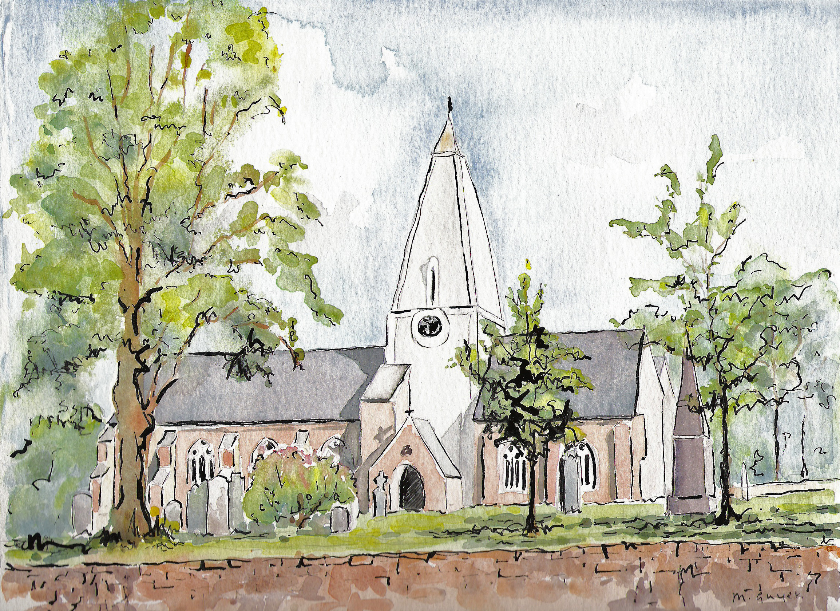Matins

Holy Trinity Church, Jersey

Sunday 17th August 2025

9th Sunday after Trinity

Processional Hymn

Still the weary folk are pining

For the hour that brings release:

And the city’s crowded clangour

Cries aloud for sin to cease;

And the homesteads and the woodlands

Plead in silence for their peace.

Judge eternal, throned in splendour,

Lord of lords and King of kings,

With thy living fire of judgement

Purge this realm of bitter things:

Solace all its wide dominion

With the healing of thy wings.

Crown, O God, thine own endeavour;

Cleave our darkness with thy sword;

Feed the faithless and the hungry

With the richness of thy word:

Cleanse the body of this nation

Through the glory of the Lord.

*Henry Scott Holland (1847-1918) (NEH490)*

Welcome and notices

Words of introduction and invitation

Beloved, we are come together in the presence of almighty God and of the whole company of heaven to offer unto him through our Lord Jesus Christ our worship and praise and thanksgiving; to make confession of our sins; to pray, as well for others as for ourselves, that we may know more truly the greatness of God’s love and shew forth in our lives the fruits of his grace; and to ask on behalf of all men such things as their well-being doth require.

Wherefore let us sit or kneel in silence, and remember God’s presence with us now.…

*Let us humbly confess our sins to Almighty God.*

***Almighty and most merciful Father; we have erred, and strayed from thy ways like lost sheep. We have followed too much the devices and desires of our own hearts. We have offended against thy holy laws. We have left undone those things which we ought to have done; and we have done those things which we ought not to have done; and there is no health in us. But thou, O Lord, have mercy upon us, miserable offenders. Spare thou them, O God, which confess their faults. Restore thou them that are penitent; according to thy promises declared unto mankind in Christ Jesu our Lord. And grant, O most merciful Father, for his sake; That we may hereafter live a godly, righteous, and sober life, to the glory of thy holy Name. Amen.***

Grant, we beseech thee, merciful Lord, to thy faithful people pardon and peace, that they may be cleansed from all their sins, and serve thee with a quiet mind; through Jesus Christ our Lord. ***Amen.***

***Our Father; who art in heaven, hallowed be thy name; thy kingdom come; thy will be done; on earth as it is in heaven. Give us this day our daily bread. And forgive us our trespasses, as we forgive those who trespass against us. And lead us not into temptation; but deliver us from evil. For thine is the kingdom, the power and the glory, for ever and ever. Amen.***

O Lord, open thou our lips.

***And our mouth shall show forth thy praise.***

O God, make speed to save us.

***O Lord, make haste to help us.*** *(stand)*

Glory be to the Father, and to the Son; and to the Holy Ghost;

***As it was in the beginning, is now, and ever shall be; world without end. Amen.***

Praise ye the Lord;

***The Lord’s name be praised.***

***The Venite***

**O come, let us’ sing unto the’ Lord: let us heartily rejoice in the’ strength of’ our sal’vation.   
Let us come before his’ presence with’ thanksgiving: and shew ourselves’ glad in’ him with’ psalms.   
For the Lord is a’ great’ God: and a great’ King above’ all’ gods.  
In his hand are all the’ corners of the’ earth: and the strength of the’ hills is’ his’ also.   
The sea is his, and’ he’ made it: and his hands pre’pared the’ dry’ land.**

**O come, let us worship, and’ fall’ down: and kneel be’fore the’ Lord our’ Maker.**

**For he is the’ Lord our’ God: and we are the people of his pasture, and the’ sheep of’ his’ hand.   
Glory be to the Father, and’ to the’ Son: and’ to the’ Holy’ Ghost;**

**As it was in the beginning, is now and’ ever’ shall be: world without ‘end’.** **A’men.**

Psalm 82

1. **God standeth in the congre’gation of ‘ princes : he is a ‘ Judge a’mong ‘ gods.**
2. **How long will ye ‘ give wrong ‘ judgement : and accept the ‘ persons ‘ of the un’godly?**
3. **Defend the ‘ poor and ‘ fatherless : see that such are in need and ne’cessity ‘ have ‘ right.**
4. **Deliver the ‘ outcast and ‘ poor : save them from the ‘ hand ‘ of the un’godly.**
5. **They will not be learned nor understand, but walk on ‘ still in ‘ darkness : all the foundations of the ‘ earth are ‘ out of ‘ course.**
6. **I have said ‘Ye are ‘ gods : and ye are all the ‘ children ‘ of the most ‘ Highest.**
7. **But ye shall ‘ die like ‘ men : and ‘ fall like ‘ one of the ‘ princes.**
8. **Arise O God, and judge ‘ thou the ‘ earth : for thou shalt take all ‘ heathen to ‘ thine in’heritance.**

**Glory be to the Father, and ‘to the ’Son: and’ to the’ Holy’ Ghost; As it was in the beginning, is now and ’ever’ shall be: world without ‘end’. A’men.**

The First Lesson

The first lesson is taken from Hebrews 11, verses 29 – 12.2

…..

Here ends the First Lesson.

***Benedicite 1-18***

***O all ye Works of the Lord’ bless ye the’ Lord:***

***O ye Angels of the Lord’ bless ye the’ Lord:***

***O ye Heavens’ bless ye the’ Lord: praise him and’ magnify’ him for’ ever.***

***O ye Waters that be above the Firmament’ bless ye the’ Lord:***

***O all ye Powers of the Lord’ bless ye the’ Lord:***

***O ye Sun and Moon’ bless ye the’ Lord: praise him and’ magnify’ him for’ ever.***

***O ye Stars of Heaven’ bless ye the’ Lord:***

***O ye Showers and Dew’ bless ye the’ Lord:***

***O ye Winds of God’ bless ye the’ Lord: praise him and’ magnify’ him for’ ever.***

***O ye Fire and Heat’ bless ye the’ Lord:***

***O ye Winter and Summer’ bless ye the’ Lord:***

***O ye Dews and Frosts’ bless ye the’ Lord: praise him and’ magnify’ him for’ ever.***

***O ye Frost and Cold’ bless ye the’ Lord:***

***O ye Ice and Snow’ bless ye the’ Lord:***

***O ye Nights and Days’ bless ye the’ Lord: praise him and’ magnify’ him for’ ever.***

***O ye Light and Darkness’ bless ye the’ Lord:***

***O ye Lightnings and Clouds’ bless ye the’ Lord:***

***O let the Earth’ bless the’ Lord: yea let it praise him and’ magnify’ him for’ ever.***

***Glory be to the Father, and’ to the’ Son: and’ to the’ Holy’ Ghost***

***As it was in the beginning, is now and’ ever’ shall be: world without ‘end’. A’men.***

The Second Lesson

The second lesson is taken from Luke, Chapter 12, verses 49 - 56

…..

Here ends the Second Lesson.

***Benedictus***

***Blessed be the Lord’ God of’ Israel: for he hath’ visited and re’ deemed his’ people;***

***And hath raised up a mighty sal’ vation’ for us: in the’ house of his’ servant’ David;***

***As he spake by the mouth of his’ holy’ Prophets: which have been’ since the’ world be’ gan;***

***That we should be saved’ from our’ enemies: and from the’ hands of’ all that’ hate us;***

***To perform the mercy promised’ to our’ forefathers: and to re’ member his’ holy’ Covenant;***

***To per’form the’ oath: which he’ sware to our’ fore father’ Abraham;   
That he would give us, that we being delivered out of the’ hand of our’ enemies: might’ serve him with’ out’ fear;***

***In holiness and’ righteousness be’ fore him: all the’ days of’ our’ life. And thou Child shalt be called the’ Prophet of the’ Highest: for thou shalt go before the face of the Lord’ to pre’ pare his’ ways;***

***To give knowledge of salvation’ unto his’ people: for the re’ mission’ of their’ sins,***

***Through the tender mercy of’ our’ God: whereby the day-spring’ from on’ high hath’ visited us;***

***To give light to them that sit in darkness, and in the’ shadow of’ death: and to guide our feet’ into the’ way of’ peace.***

***Glory be to the Father, and’ to the’ Son: and’ to the’ Holy’ Ghost;***

***As it was in the beginning, is now and’ ever’ shall be: world without’ end’. A’men.***

The Apostles' Creed

***I believe in God the Father almighty, maker of heaven and earth; and in Jesus Christ, his only Son our Lord, who was conceived by the Holy Ghost, born of the virgin Mary, suffered under Pontius Pilate, was crucified, dead and buried. He descended into hell. The third day he rose again from the dead; he ascended into heaven, and sitteth on the right hand of God the Father almighty. From thence he shall come to judge the quick and the dead.* *I believe in the Holy Ghost, the holy catholic Church, the communion of saints, the forgiveness of sins, the resurrection of the body, and the life everlasting. Amen.***

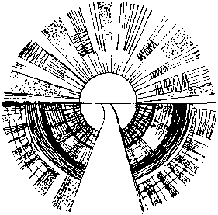

The Lord be with you, ***and with thy spirit.***

Let us pray.

Lord have mercy upon us ***Christ, have mercy upon us.***

Lord, have mercy upon us.

***Our Father, which art in heaven, Hallowed be thy Name, Thy Kingdom come, Thy will be done, in earth as it is in heaven. Give us this day our daily bread; And forgive us our trespasses, As we forgive them that trespass against us; And lead us not into temptation, But deliver us from evil. Amen.***

O Lord, shew thy mercy upon us.

***And grant us thy salvation.***

O Lord, save the King.

***And mercifully hear us when we call upon thee.***

Endue thy Ministers with righteousness.

***And make thy chosen people joyful.***

O Lord, save thy people.

***And bless thine inheritance.***

Give peace in our time, O Lord.

***Because there is none other that fighteth for us but only thou, O God.***

 O God, make clean our hearts within us.   
***And take not thy Holy Spirit from us.***

The Collect for the day

Almighty God, who sent your Holy Spirit to be the life and light of your Church: open our hearts to the riches of your grace, that we may bring forth the fruit of the Spirit in love and joy and peace; through Jesus Christ our Lord.

***Amen.***

The Second Collect, for Peace

O God, who art the author of peace and lover of concord, in knowledge of whom standeth our eternal life, whose service is perfect freedom: defend us thy humble servants in all assaults of our enemies; that we, surely trusting in thy defence, may not fear the power of any adversaries, through the might of Jesus Christ our Lord.

***Amen.***

The Third Collect, for Grace

O Lord our heavenly Father, almighty and everlasting God, who hast safely brought us to the beginning of this day: defend us in the same with thy mighty power; and grant that this day we fall into no sin neither run into any kind of danger, but that all our doings may be ordered by thy governance, to do always what is righteous in thy sight; through Jesus Christ our Lord.

***Amen.***

Hymn

# Let saints on earth in concert sing

With those whose work is done;

For all the servants of our King

In earth and heaven are one.

One family, we dwell in Him,

One Church, above, beneath;

Though now divided by the stream,

The narrow stream of death.

One army of the living God,

To his command we bow;

Part of His host has crossed the flood,

And part is crossing now.

E’en now to their eternal home

There pass some spirits blest,

While others to the margin come,

Waiting their call to rest.

Jesu, be thou our constant Guide;

Then, when the word is given,

Bid Jordan’s narrow stream divide,

And bring us safe to heaven.

*Charles Wesley (1707-88) (NEH396)*

Address – Angela Le Sueur

Hymn

The Kingdom of God is justice and joy,

For Jesus restores what sin would destroy;

God’s power and glory in Jesus we know,

And here and hereafter the kingdom shall grow.

The kingdom of God is mercy and grace,

The captives are freed, the sinners find place,

The outcast are welcomed God’s banquet to share,

And hope is awakened instead of despair.

The kingdom of God is challenge and choice,

Believe the good news, repent and rejoice!

His love for us sinners brought Christ to his cross,

Our crisis of judgement for gain or for loss.

God’s kingdom is come, the gift and the goal,

In Jesus begun, in heaven made whole;

The heirs of the kingdom shall answer his call,

And all things cry “Glory!” to God all in all.

*Bryn Rees (1911-1983) (SP254)*

Prayers of intercession

Lord, in your mercy, ***hear our prayer.***

... Merciful Father***, accept these prayers for the sake of thy Son,***

***our Saviour Jesus Christ. Amen.***

Offertory Hymn

O praise ye the Lord!

All things that give sound,

Each jubilant chord,

Re-echo around;

Loud organs, his glory

Forth tell in deep tone,

And sweet harp, the story

Of what He has done.

O praise ye the Lord!

Thanksgiving and song

To Him be outpoured

All ages along:

For love in creation,

For heaven restored,

For grace of salvation,

O praise ye the Lord!

Amen. Amen.

*Henry Williams Baker (1821-77) (NEH 427)*

O praise ye the Lord!

Praise Him in the height;

Rejoice in his word,

Ye angels of light;

Ye heavens adore him

By whom ye were made,

And worship before him,

In brightness arrayed.

O praise ye the Lord!

Praise him upon earth,

In tuneful accord,

Ye sons of new birth;

Praise him who has brought you

His grace from above,

Praise Him who has taught you

To sing of His love.

The Blessing

The Lord bless you and watch over you, the Lord make his face shine upon you and be gracious to you, the Lord look kindly on you and give you peace; and the blessing of God almighty, the Father, the Son and the Holy Spirit, be amongst you and remain with you always. **Amen.**

***Refreshments are served in the Lady Chapel. Please do join us!***

**To make an offertory donation to church,**

**please scan the QR. Thank you.**

CCL760416